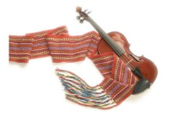
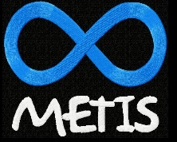
ᐅᐦᐱᑭᐦᐋᐊᐧᓱᐤ Ohpikihâwasow
(in Cree means s/he raises a family, s/he raises children)

For Caregivers of Metis Children/ Youth
Saturday November 23, 2019
10-3
@Ooknakane Friendship Centre
146 Ellis St, Penticton, BC
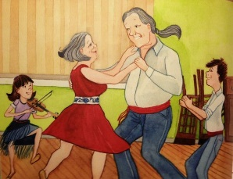

Special guest Bev Lambert
Please register with
Sheila Martial Ridden – Metis Roots Practitioner
roots@mcsbc.org
cell/office # (250)878 0860
In partnership with:
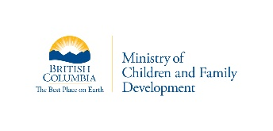
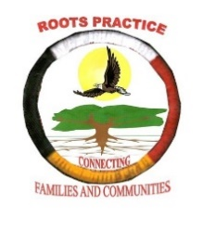
Penticton Metis Association

Vermilion Forks Metis Association

